**Required Steps to Deploy Prometheus and Grafana into Minikube Cluster Using Helm Chart**

Prometheus is used to monitor Kubernetes Cluster and other resources running on it.   
Grafana helps to visualize metrics recorded by Prometheus and display them in dashboards.

* Start Minikube

1. Run following command to start minikube

**minikube start**

* Install Helm

1. Download Helm  
   <https://github.com/helm/helm/releases>
2. Unzip the downloaded folder and set that “path” at environment variables.
3. Test command ‘helm’ in PowerShell.

* Install Prometheus

1. Add Prometheus repository

**helm repo add prometheus-community https://prometheus-community.github.io/helm-charts**

1. Install provided Helm chart for Prometheus

**helm install prometheus prometheus-community/prometheus**

1. Expose the prometheus-server service via NodePort

**kubectl expose service prometheus-server --type=NodePort --target-port=9090 --name=prometheus-server-np**

1. Check services

**kubectl get svc**

* Access Prometheus UI

1. Expose service URL

**minikube service prometheus-server-np –url**

1. Prometheus UI

* Install Grafana

1. Add Grafana helm repo

**helm repo add grafana https://grafana.github.io/helm-charts**

1. Install Grafana chart

**helm install grafana grafana/grafana**

1. Expose Grafana service via NodePort to access Grafana UI

**kubectl expose service grafana --type=NodePort --target-port=3000 --name=grafana-np**

1. Check exposed service

**kubectl get services**

* Get Grafana admin credentials

**kubectl get secret --namespace default grafana -o jsonpath="{.data.admin-password}" | base64 --decode ; echo**

* Access Grafana UI

1. Expose Grafana service in minikube

**minikube service grafana-np –url**

1. Access UI and enter admin credentials to login

1. Configure Prometheus Data source (use [prometheus-server:80](http://prometheus-server/) URL)

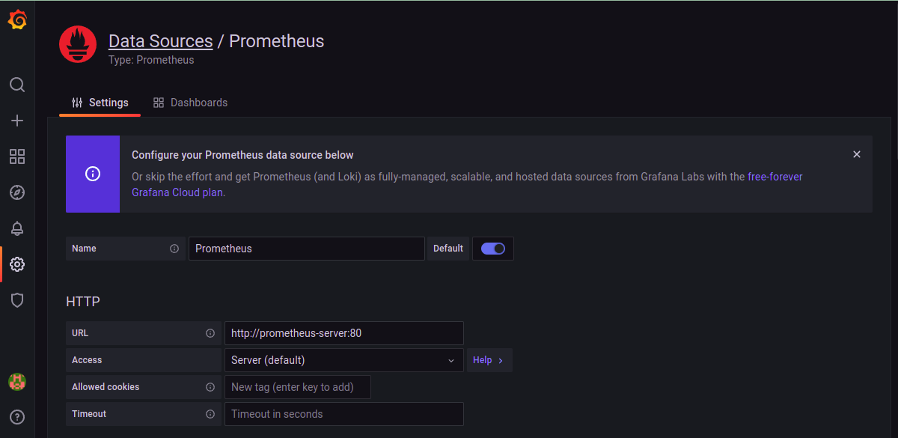

1. Import default Prometheus dashboards

1. We can also import community based Grafana dashboards with 6417 id and in the dashboard configuration we need to select the Prometheus Data source we created in step 3

1. Once we confirm the Import dialog, we will be redirected to the new Dashboard where we can see cluster’s information in Dashboard

